**Experiment Title-3.1.1**

**Student Name: ADITYA RAJ** **UID:21BCS8948**

**Branch: CSE**  **Section/Group: ONBCS703/A**

**Semester: 3rd Date of Performance:12/11/2022**

**Subject Name: DBMS Subject Code:21 CSH-214**

**1. Aim/Overview of the practical:**  **Create Local procedure to calculate the simple interest by passing the values of principal, rate and time.**

**2. Source Code:**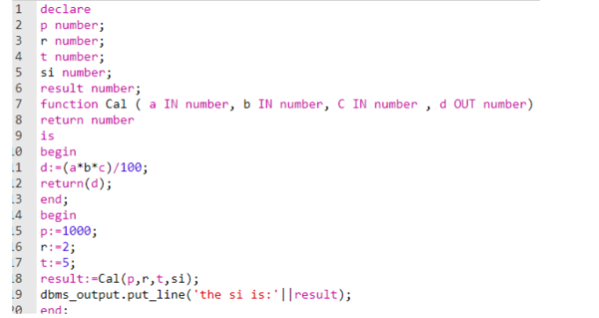

**3. Result/Output:**

